*IT24100405 – Kumara K.S.J.L*

*PS Lab 05*

**1. Import the dataset (’Exercise – Lab 05.txt’) into R and store it in a data frame called ”Delivery Times”.**

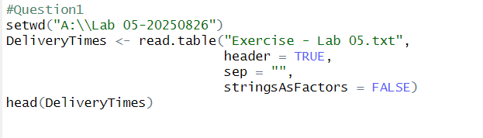

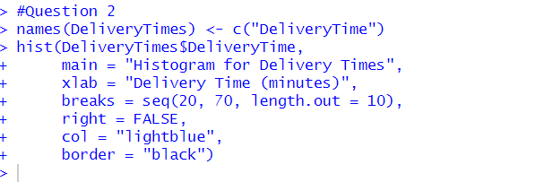**2. Draw a histogram for deliver times using nine class intervals where the lower limit is 20 and upper limit is 70. Use right open intervals.**

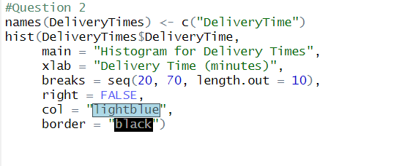

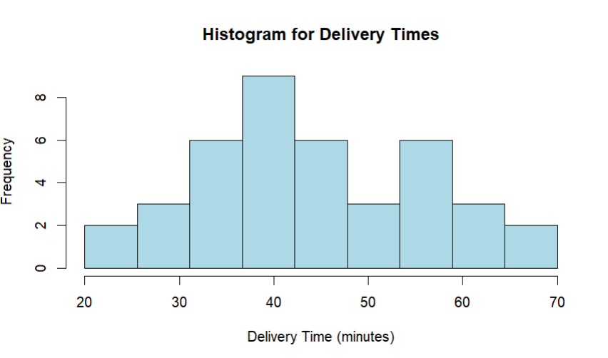

**3. Comment on the shape of the distribution.**

*This distribution is approximately symmetric: Because left and ride sides centers are fairly balanced. Similar to normal distribution and not extreme outliers or long tails and also its perfectly smooth because of the small sample.*

**4. Draw a cumulative frequency polygon (ogive) for the data in a separate plot.**

